**WEB TECHNOLOGIES AND PROGRAMMING**

**FINAL PROJECT**

**PROJECT NAME:** NBAlatest

**GROUP MEMBERS:**

Alissa Çenga,

Klaid Merdhoci,

Rubin Aga.

**1. Executive Summary**

**1.1 Project Overview**

We have decided to create a website which will provide its users the latest news according to the famous basketball league of North America NBA. From the website, the user can be informed about the latest scoops happening, the standings of the 30 participants of the league, the player’s latest happenings, all the results from the played games, and the upcoming ones.

The user will be able to register into the website, and the admin will be able to manage the registered users and access them while being stored into a specific database. After being registered the users will have the option to log in into the website, and access one of the best features of the website, the Shop section. They will be able to choose from three categories (which will be updated later on): Accessories, Shorts, and Shirts. In this section, all the merch of the 30 contestants of the league will be available. Each item will be accessed from the database and the user will be able to access it while clicking onto the Add to Cart.

We aim to improve the user experience, this is why a Feedback section will be available into the website, where each user can leave its feedback, let this be questions, constructive criticism, and so on. The feedback will directly be stored into the database and can be accessed only by the admin of the webpage.

**1.2 Purpose and Scope of this Specification**

Our purpose as developers is to improve the user’s experience and simplify as much as we can the access to the latest NBA news and shop the huge variety of merch offered by the NBA teams. The website is going to provide the following:

1. Access the latest news.

2. Contact the team and leave user feedback.

3. Shop the products offered in the products section

4. Register into our app.

5. Log in as simple users or as admin, in order to provide some statistics regarding the website.

**2. Requirements**

|  |  |  |  |  |  |
| --- | --- | --- | --- | --- | --- |
| **Req#** | **Requirement** | **Comments** | **Priority** | **Date Rvwd** | **SME**  **Reviewed / Approved** |
| BR_P_01 | The website should be responsive. | Whenever the user accesses the website from different screen sizes the format should be unchangeable | 1 | 8/06/22 | A.Cenga,  K.Merdhoci,  R.Aga |
| BR_P_02 | The website should be dynamic. | In order to create a dynamic website, we shall include PHP. | 1 | 8/06/22 | A.Cenga,  K.Merdhoci,  R.Aga |
| BR_P_03 | The website should validate the user information. | The validation should be performed using PHP and javascript for different regEx. | 1 | 8/06/22 | A.Cenga,  K.Merdhoci,  R.Aga |
| BR_E_04 | The website should have a unified UI | The CSS should be the same through all webpages, and the UI should be of the same type. | 2 | 8/06/22 | A.Cenga,  K.Merdhoci,  R.Aga |
| BR_E_05 | The website should contain a minimum of 10 pages. | Including views and php files. | 2 | 8/06/22 | A.Cenga,  K.Merdhoci,  R.Aga |
| BR_E_06 | The website should contain big buttons that will connect pages to one another |  | 2 | 8/06/22 | A.Cenga,  K.Merdhoci,  R.Aga |
| BR_E_07 | The website should contain different views for different priority users. | The admin’s view will differ from the regular user since additional features will be available. | 2 | 8/06/22 | A.Cenga,  K.Merdhoci,  R.Aga |
| BR_E_08 | The website should be connected to a functional database. |  | 2 | 8/06/22 | A.Cenga,  K.Merdhoci,  R.Aga |
| BR_E_09 | The shop section should access the displayed items from the database. |  | 2 | 8/06/22 | A.Cenga,  K.Merdhoci,  R.Aga |

**3. Product/Service Description**

Our website will be divided into six main section: Home, About, Contact, Shop, Log in, and Registration. In this section we will describe how each page is structured and the respective functionalities.

The section of our website will be included in the Menu. The menu will be available in each page along with the name of the website “NBAlatest”.



The footer section of our website, which will be available in all the pages except for the Login and Register section, will contain information regarding the location of the Website, a number from which the users can contact the staff of the website, the creator’s emails, the button allowing the admin to log in, and the copyrights fragment.

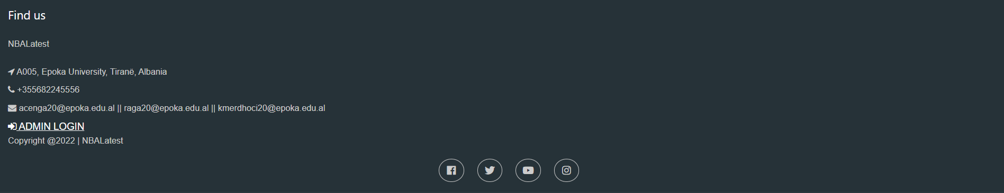

**3.1 Home**

As the user first opens the website, the page which will be primarily accessed is going to be the homepage. The homepage will include all the news and articles written and uploaded from our Journalism team. The latest news will be displayed when your first open the Home Page as a slideshow. This page is built mainly by using HTML and CSS, but a short script section is available too.

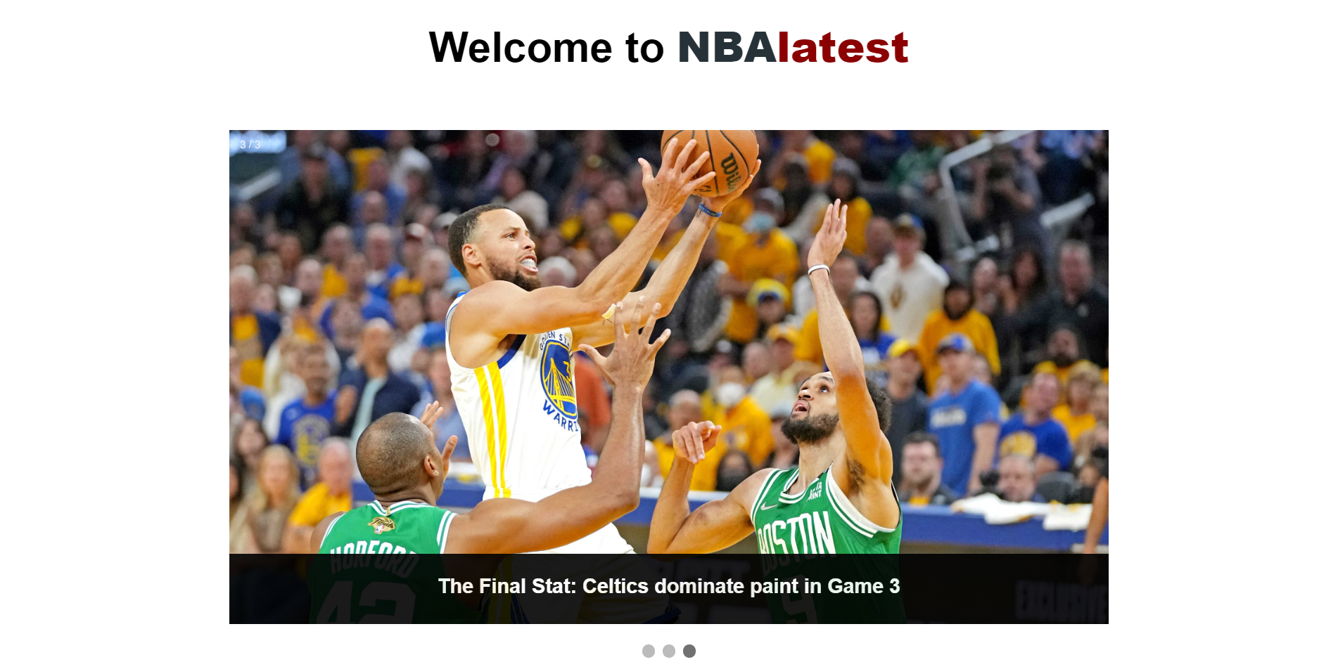

Under this section, some news related to leagues other than NBA will be displayed. When clicking them, the users will be redirected to the websites where the articles are located.

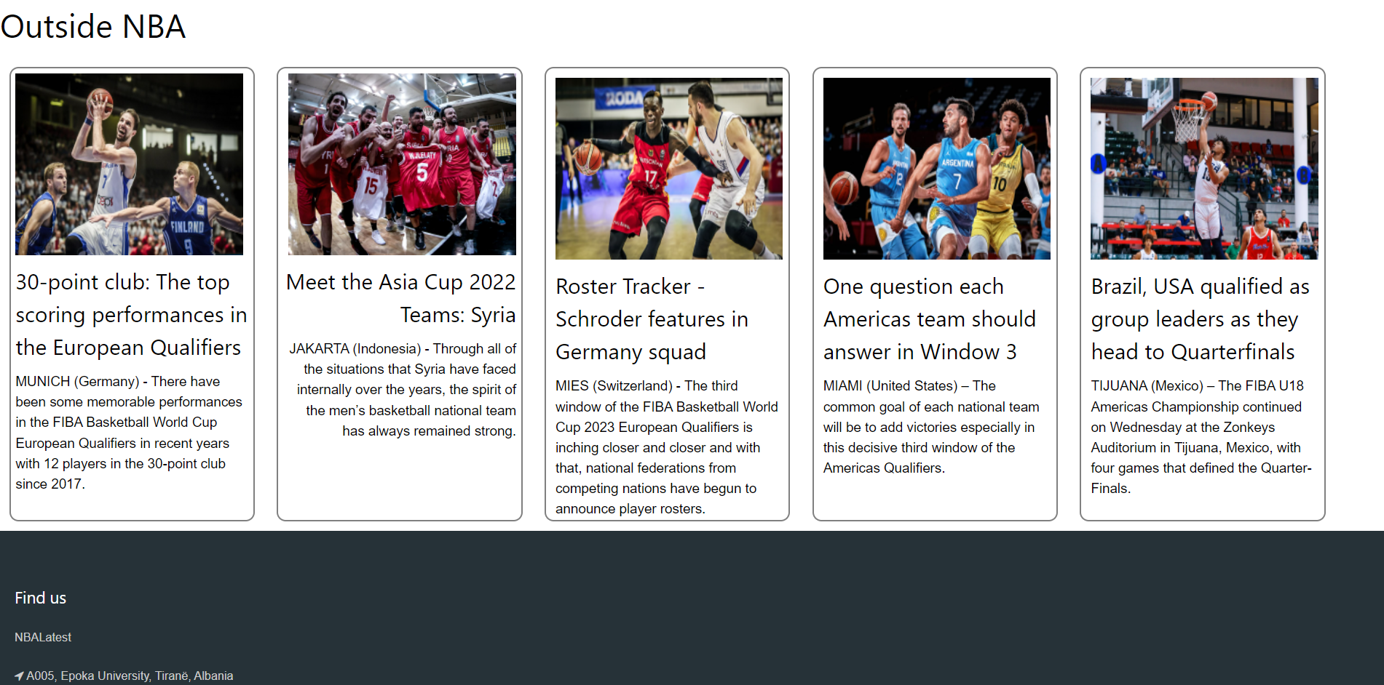

**3.2 About**

This page will provide some information regarding the main functionalities of the website and the origin of its creation. It will be divided through an internal menu which will contain the following sections: Who we are, Meet the creators, and Get in touch which will redirect the user to the Contact Page explained below.

At first in every section of this sous-menu, the “header” About Us will be available at all times. In this pseudo-header the mission of the website will be displayed. Then by clicking onto Who we are, a brief explanation regarding the ideation and scope of NBAlatest will be displayed. When clicking Meet the Creators, the history of how the creators decided to join together into creating the website and much more relevant information will be displayed.

This page is built mainly with HTML and CSS.

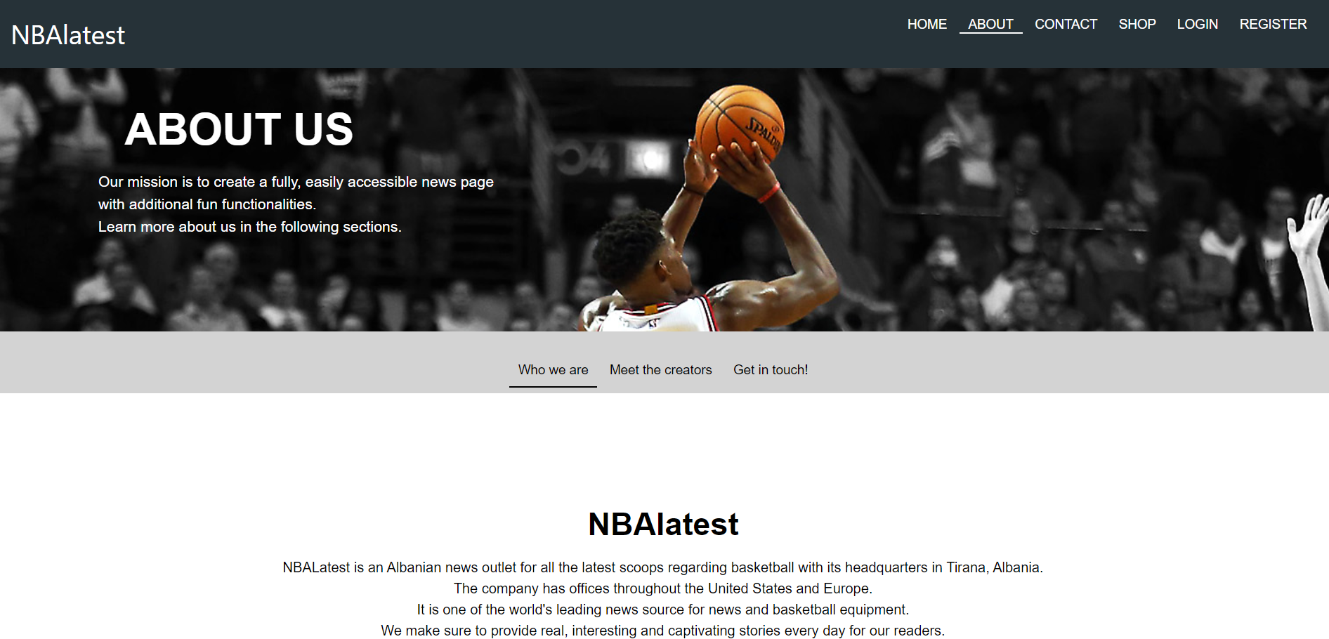

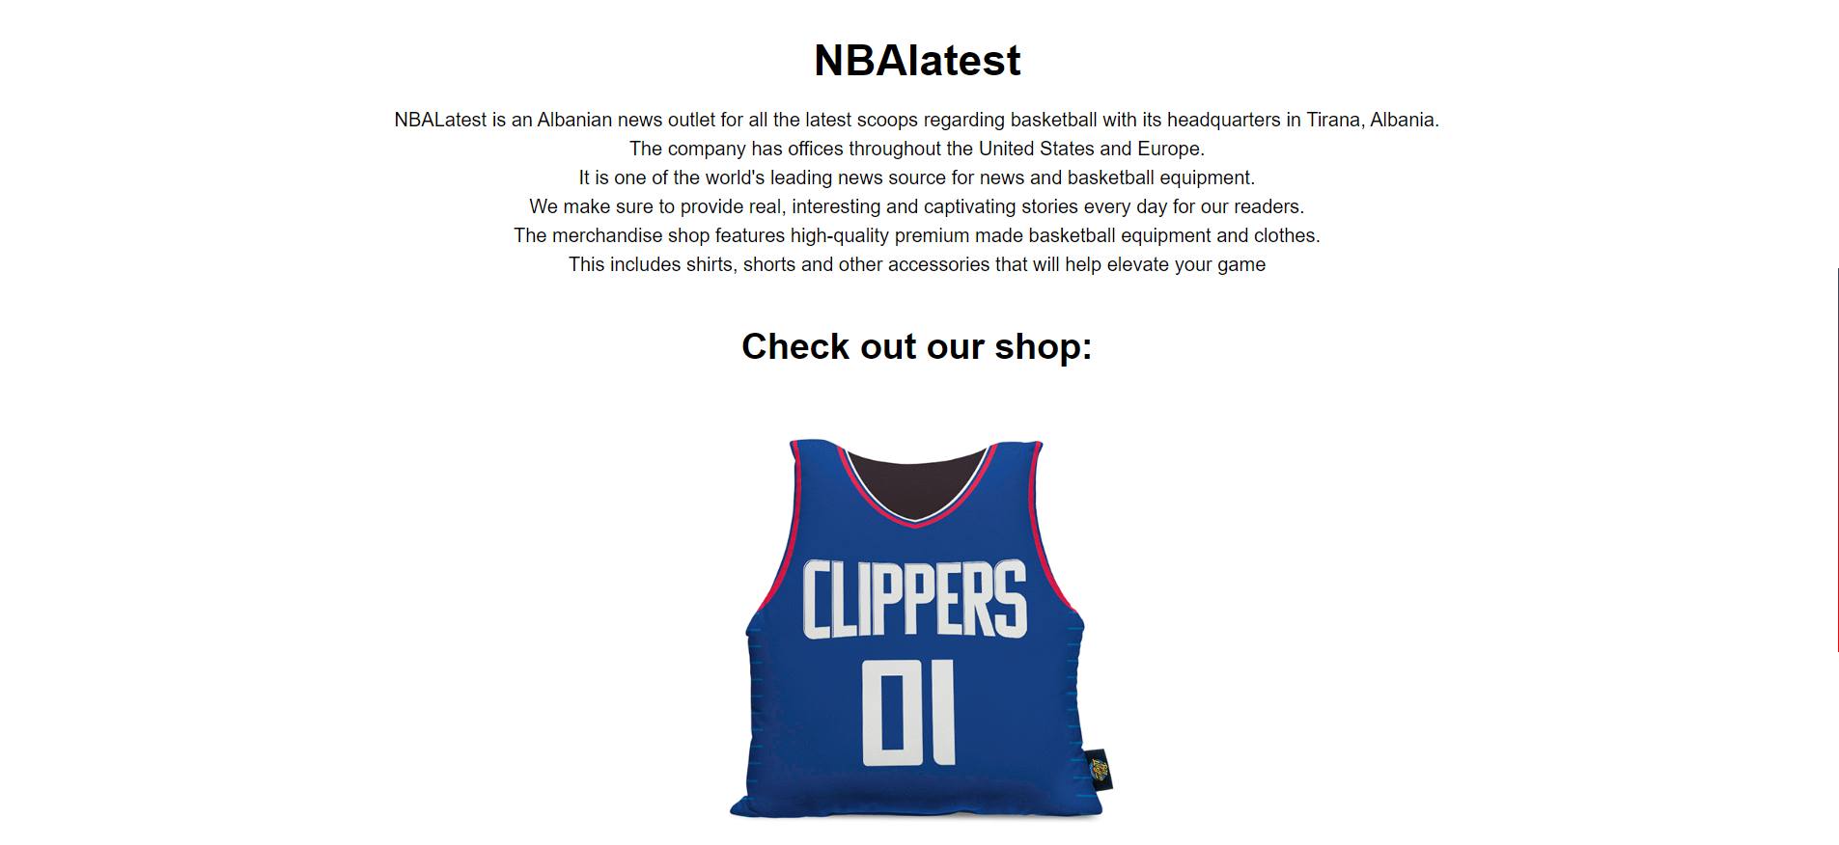



*Footer is present in this page.

**3.3 Contact**

This section of the website can be accessed while clicking the Contact link found in the Menu or, by clicking the Get In touch! Menu link found in the About Page. In this page the user will be able to send some feedback related to the page, take a look at some User Reviews, and access the location of the website through an incorporated map.

The first thing to be displayed is going to be the form, containing two inputs responsible for the first and last name of the user, a dropdown box responsible for the Country from which the user is sending the feedback, and a Text Area where the user will insert its comments. The last input element of the form will be of type Submit. This will represent the input button which will allow the user to “Submit” the information. Once the user clicks this button and he/ she has correctly filled all the input sections, a new row will be inserted into the database containing all the information gathered from the form. This part will be performed using PHP and the knowledge gathered from the Lab sessions. The information will be submitted whenever the text area is going to be filled.

This addition will be performed into the messagefile.php file. We are going to preserve into variables the information gathered from the inputs of the feedback form. Then after preserving them, a connection to the database of the website will be created and by using a simple INSERT into query, we will create the new row in the messages table of our database.

Besides the feedback form, a user review section will be provided, where the top received reviews will be displayed. The last section will be Our Location, where a map showing the location of “Epoka University” will be displayed using an <iframe></iframe> element.

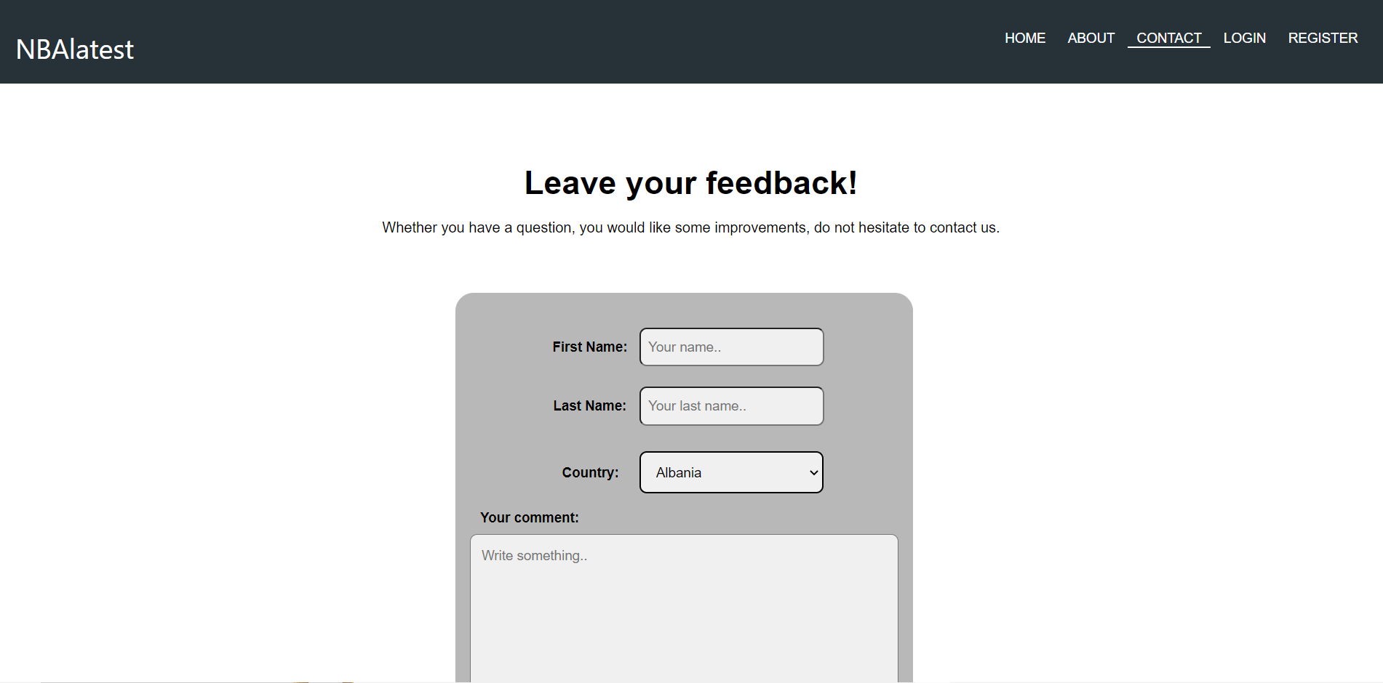



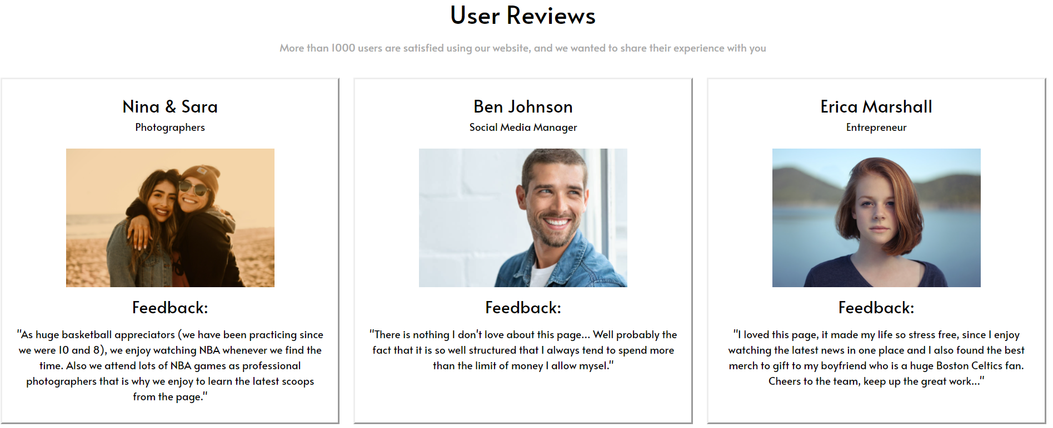

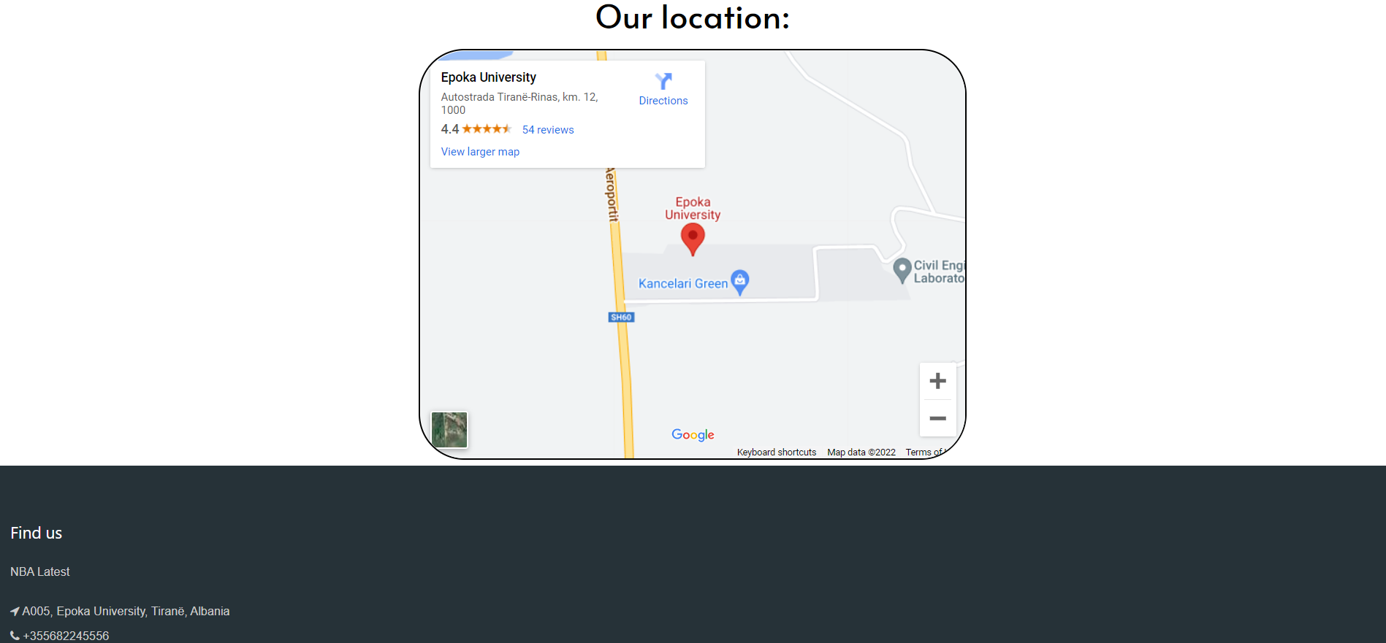

**3.4 Shop**

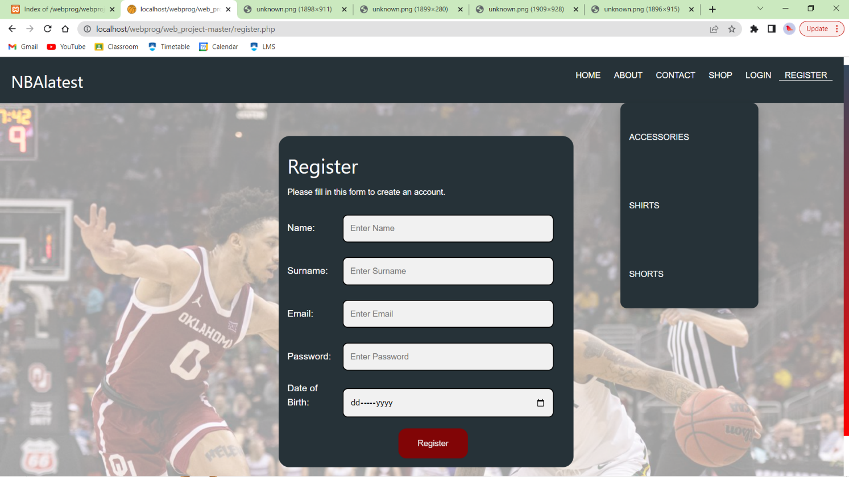

In order to generate the table of products, a connection is made with the database. In order to make the table with 3 columns, every time a product is called from the database, we keep track of the column it gets in and once 3 columns are created, a new row is made. The table contains the image, price and name of the elements. In hidden input elements we pass information through the post method. A hidden id keeps track of the id of the product we have displayed. When the add to cart button is clicked, it is checked by the server side php. The php code checks if the item added is already existing in the session cart. If it is not then all the items taken from the form are added into an array and appended. If the item is already found in the list, we check if the item exists inside the list and keep a flag variable to indicate its presence or not.

To delete an item from the list, we match the id of the product we want to delete from the cart table to the corresponding element in the session cart. When that match is found, the value is removed from the session cart with 'unset'. If we want to delete all the items from our cart, clicking the 'Remove All Items' performs just that. It unsets the session cart and empties it.

In the session cart, in order to keep track of all the elements added we create a table. The table is created by looping through all the cart. Inside the table, the product's name, quantity and price is displayed. Since we have a quantity and price per product we also calculate the total amount of money per product. After calculating this, in the presence of more products, a complete total sum of all the products is made showing the final amount to be paid. Then the total is printed in the bottom of the table with a floating point precision of 2. 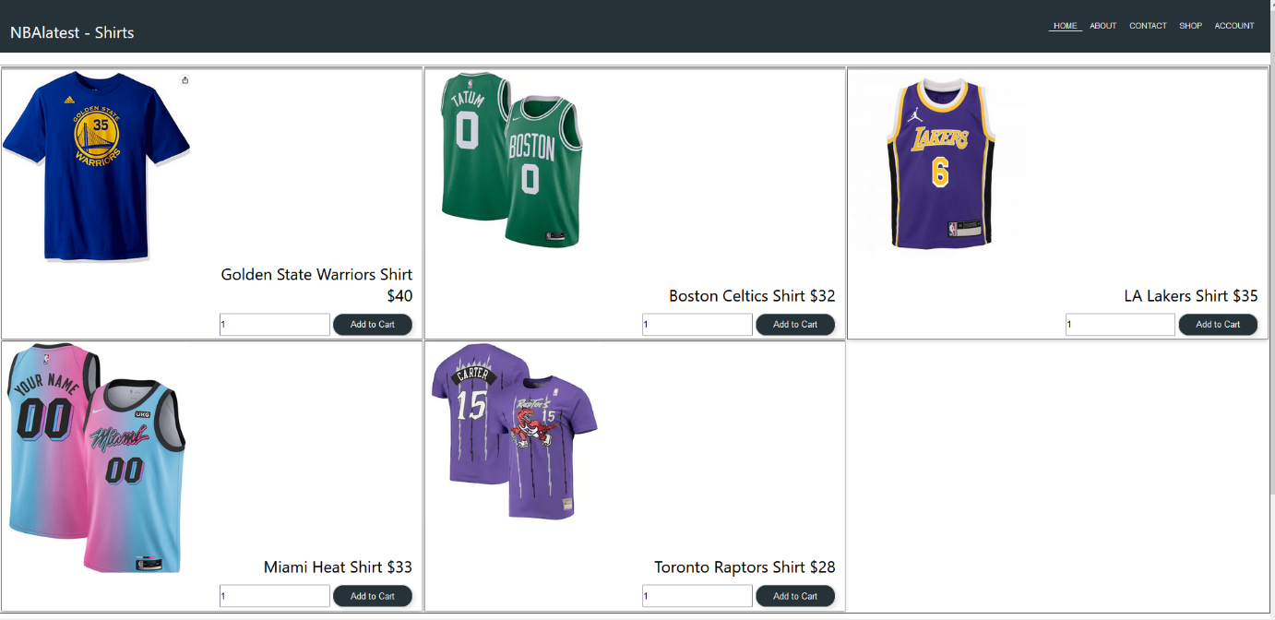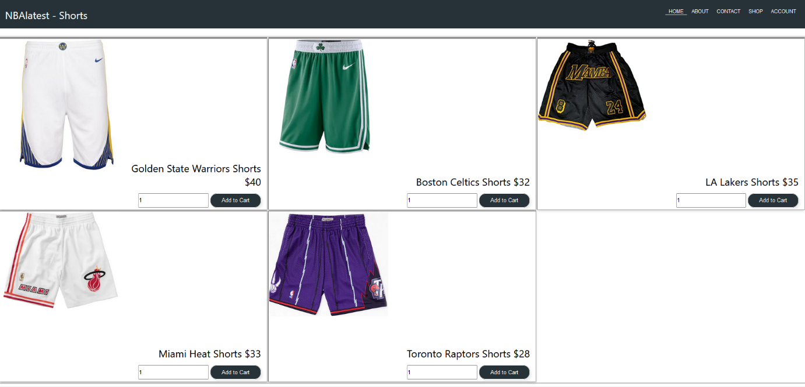

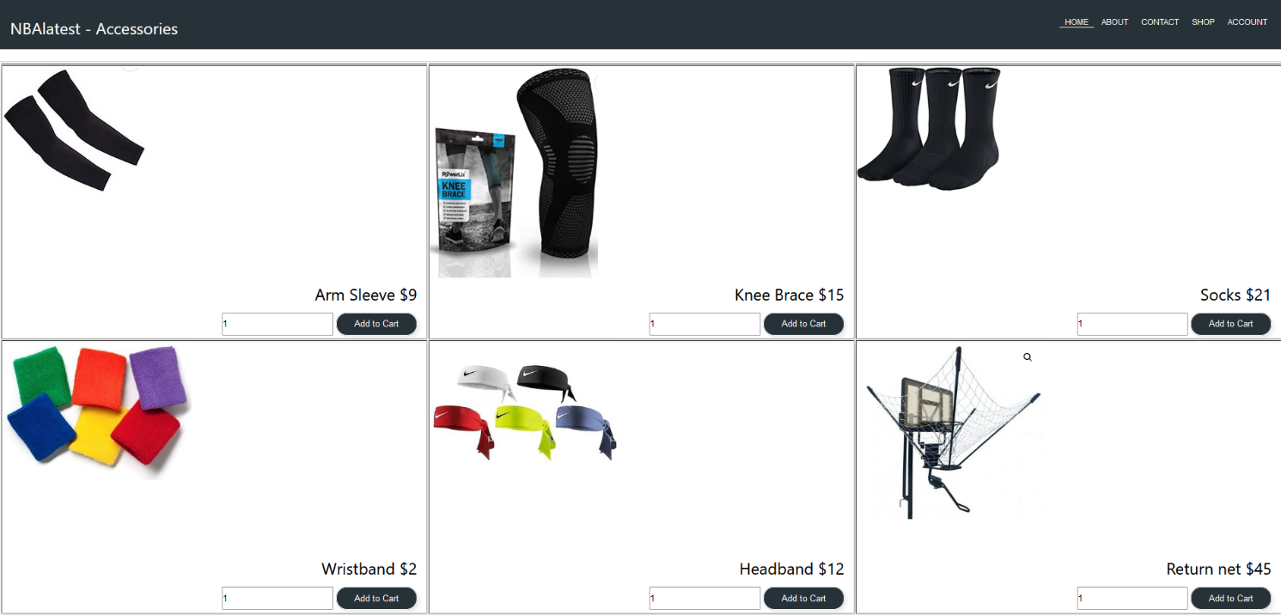

**3.5 Login**

The next section of the website is going to be the Login section which will enable the user to login into the page. This section will be mainly constructed using a form that has three input boxes. One responsible for the email of the user, the other for the password and the last input of type submit will send the information to the loginfile.php. Into this file the input data gathered from the form will be preserved into variables, using PHP, and it will check if the user account is available as a row into the users table found in our database. If not, an error message will be displayed in the login page.

In the loginfile.php an else condition will set the login to fail whenever the entered values are not valid. By using a php tag in the main login.php file we will check whether this variable is set to fail or not. If so the above mentioned error message will be displayed.

This section will also contain a link which will take the user to the Register Page in the website which will allow the user to create an account.

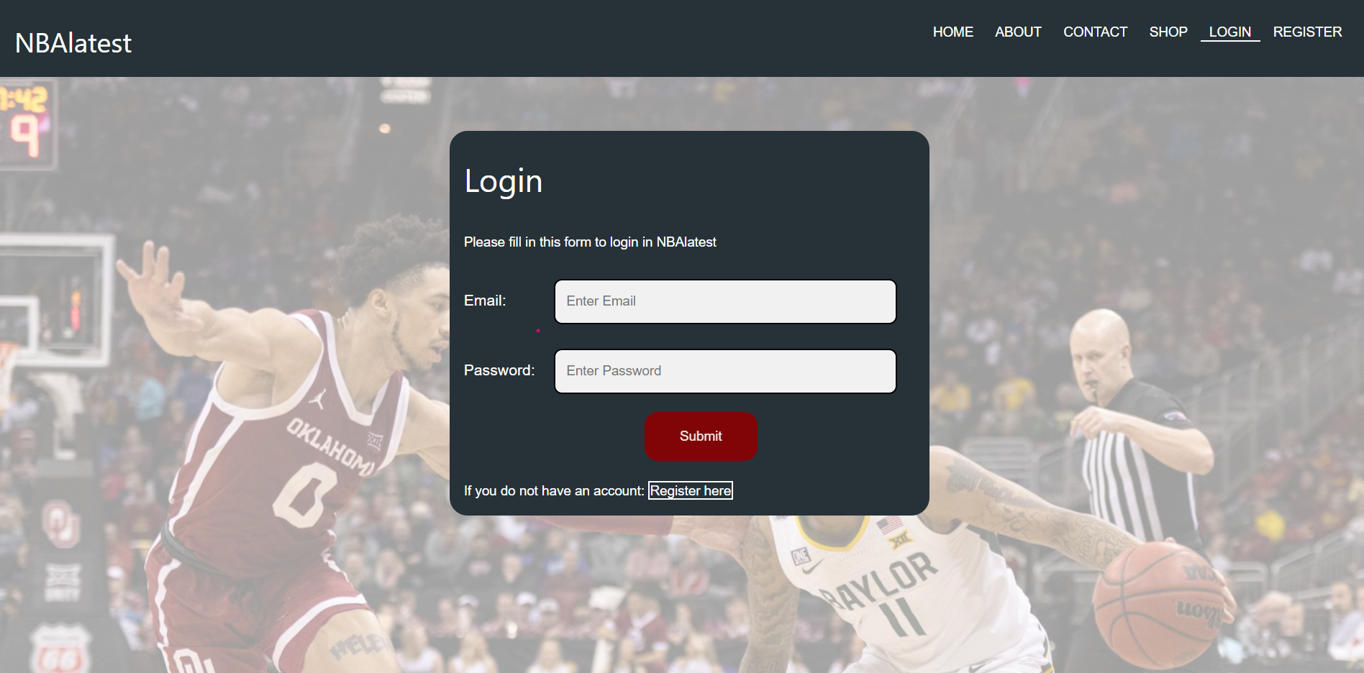

**3.5.1 Login Update**

When the user is logged in into the website, he will be able to modify the details of his account while accessing the Update page. In this page the data of the user will be displayed as initial value into the input boxes of the same form as that in the Register page. This data is generated by accessing the data added into the Users table of the database.

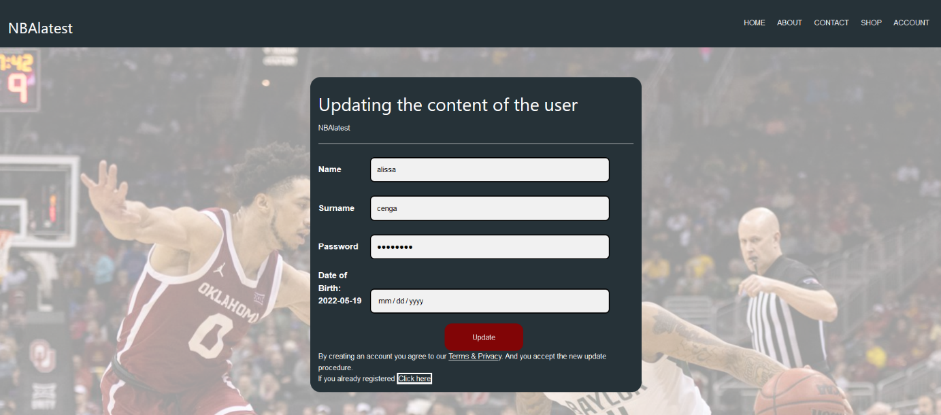

**3.6 Register**

This section will contain a form which will enable the user to create a new row into the users table of the database. This form will contain 6 input elements respectively responsible for: the user’s name, surname, email, password, date of birth, and the last input element will be of type Submit. This last element will enable the connection of the form to the createacc.php file. Into this file we will take care of the insertion of the user data into the database. We will first check if the submit button is set. Then if the condition is met, we will preserve each data gathered from the form into related variables. The first condition which will apply to all variable values equally is going to be the emptiness. If the inputs are left empty, a variable named signup will be set to empty and transferred to the register.php file. In the file a php tag will be already enabled which will assign to a variable named “signupCheck” the previous value. We will then form a set of conditions, the first checking whether this variable’s value is equal to empty. If so, an error according to this case will be displayed.

A bunch of checks will be transferred from one file to the other until finally passed. The minute that the signup variable’s value is equal to success, using a simple insert into query we will insert the inputted data from the user, into a new row of our users table in the database. (Obviously at first the connection to the database must be performed.) Once created the success message will be displayed.

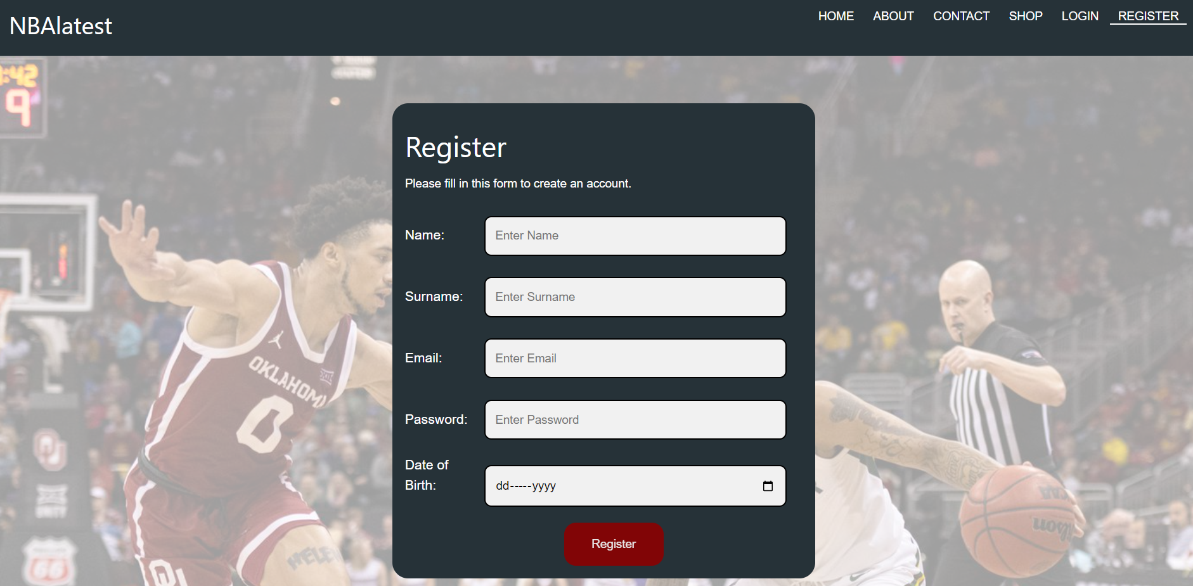

**3.7 Admin Dashboard.**

The admin will be able to login into the website when clicking the ADMIN Login link found in the footer of the website. When the admin logs in a new view will be enabled, only for this type of user. This view will enable the admin to control the users and messages received into the website. While utilizing the concept of files we have added to buttons one for the users and one for the messages which through the aid of PHP are going to access the user table and messages table and write all their content using the SELECT query into the needed excel files.

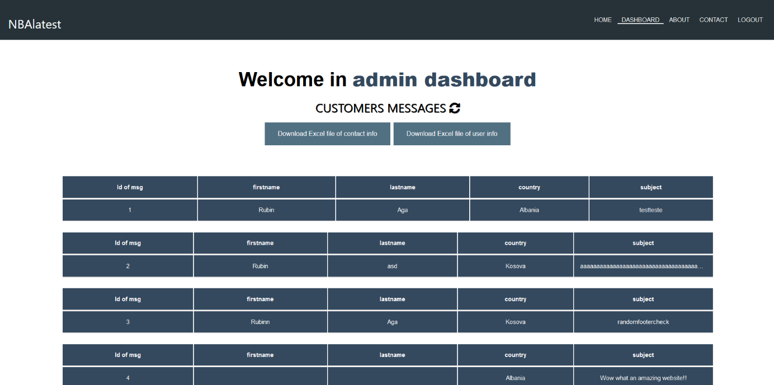

**4.Database**

The database “web_project” is the database which will be used to store and access the data from the website.

This database will be made off of 6 tables:

1. Accessories table.

This table will be used to store and access the items found in the Accessories section of the Shop page. Each accessory will have a unique id, name, actual_name, price, and quantity as attributes. The name attribute will be used to display the images in the shop page of the website meanwhile the actual_name and price attributes will be used to display the name and price of the items in the Shop page.

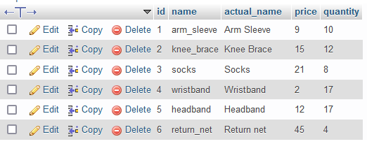

1. Admin table.

This table will store the data of the admins of the page. It will be used while logging in as an admin in order to check whether the entered data matches the values stored in the rows of the table. Each admin will have an id which will be unique, an email, password, and timestamp (responsible for the time of creation or insertion of the user as an admin).



1. Messages table.

This table will be used to store the feedback gathered from the users in the Contact page of the website. It will contain as attributes the input labels of the form found in the Contact page. These attributes are: the ids (unique for each message), firstname, lastname, country, subject (the comment inserted in the textArea) , and the timestamp from when the feedback was submitted.

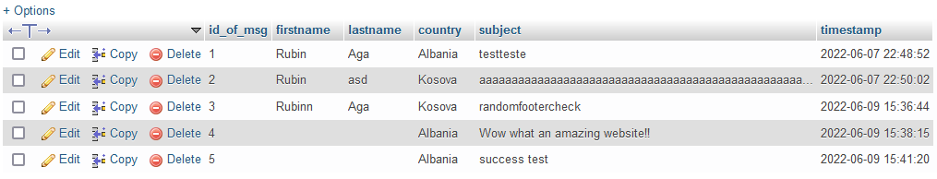

1. Shirt Table

This table will be used to store and access the items found in the Shirts section of the Shop page. Each shirt will have a unique id, name, actual_name, price, and quantity as attributes. The name attribute will be used to display the images in the shop page of the website meanwhile the actual_name and price attributes will be used to display the name and price of the items in the Shop page.

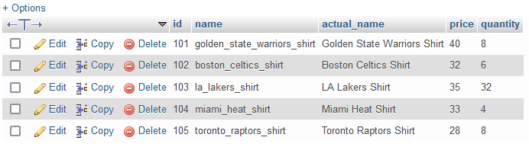

1. Shorts Table.

This table will be used to store and access the items found in the Shorts section of the Shop page. Each pair of short will have a unique id, name, actual_name, price, and quantity as attributes. The name attribute will be used to display the images in the shop page of the website meanwhile the actual_name and price attributes will be used to display the name and price of the items in the Shop page.

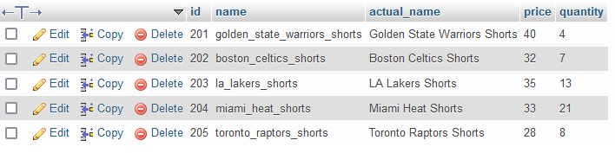

1. User Table.

This is the last table of the database but one of the most important ones. In this table all the users logged in will take form as rows of the table. The data will be submitted and accessed while registering into the Register page of the website. The attributes of this table will be the same as the labels of the inputs into the Register Form. These attributes are: a unique id, name, surname, email, password, date of birth, and timestamp which specifies the time when the user first registers into the website. This table will be used also when checking through the login page whether the user exists or not. To do so we will access using a query only the email and password of each row.

